Budget Status — Production Verification
06 September 2026 · Round 2 · Deployment approved by the user. Initial feature version 1.113.0; retained and rechecked in GL 1.115.0.

Outcome
Compact Search and Presentation layout is live. Show Summary starts unchecked. Print produces PDF and PowerPoint using the reporting service, with current filters and presentation and every matching department. PowerPoint contains page artwork images. No previous-period comparison was added.
Suite | Passed
Dashboard regression | 190/190
Report API and totals | 51/51
Print menu / 1.113.0 | 14/14
Latest release / 1.115.0 | 14/14
The later-release check repeats the Print/layout suite to verify concurrent GL changes preserved this feature. Database scripts installed successfully; all three reporting workers are active. Six report API jobs (1002–1007) and actual browser downloads succeeded. No recipients or delivery records were created. Live 401/400/404 passed; 403 was tested using local fixtures. Separate-user privilege/ownership tests were not run; deployed guards were reviewed.

Latest live search
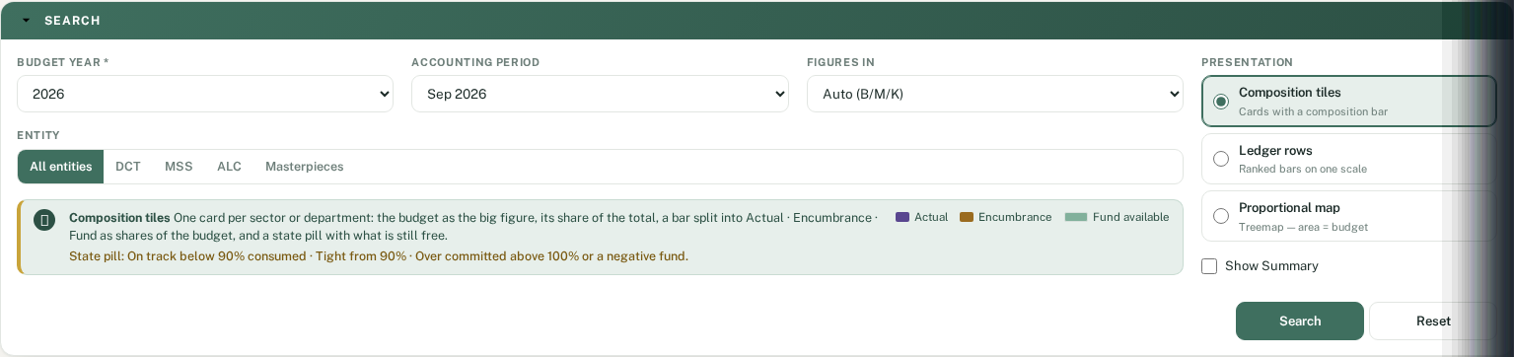

Latest live Arabic search
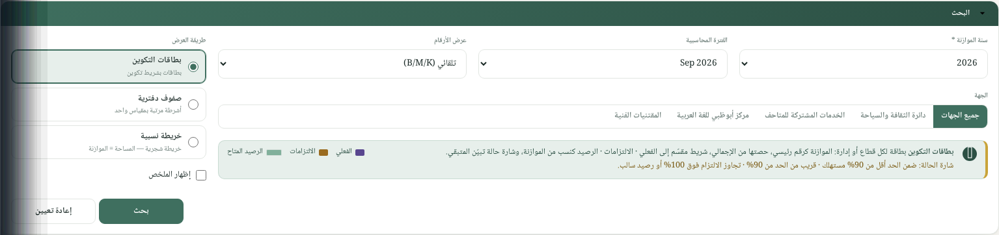

Deployment and rollback
GL-only release 20260905201058, previously 20260904081416. Later GL 1.115.0 is at release 20260905202533 and includes these changes. Do not roll back later unrelated changes: reverse only this feature’s hunks. Worker backups are /opt/rpt-worker/backups/budget-status-20260906 on vm180/181/182. Full details are in GL/docs/budget-status-review.md and deployment-notes.md.

Evidence
The dated workbook contains every check and links to machine-readable results. evidence_06-Sep-2026-01 contains browser screenshots, real PDF/PPT downloads, report run metadata and the dashboard cube used for reconciliation. These round-2 files contain production financial data; round-1 samples contain synthetic data.

